BIO-490 Glossary

Term | Meaning
AAGR | Annual Average Growth Rate:  AAGR = [(Growth Rate)y + (Growth Rate)y+1 + … (Growth Rate)y+n] / N  y = year  N = total period in years
B2B | Business-to-business
B2C | Business-to-consumer
CAGR | Compound Annual Growth Rate:  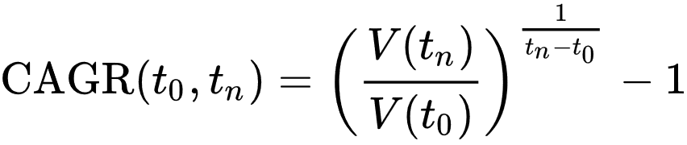  The CAGR equals the exponential growth rate when being calculated for just one year. It basically enables averaging non-linear growth better than the AAGR (which basically assumes linear growth).
Due diligence | In the context of a startup, typically a careful assessment of all critical company parameters (sales data, IP, FTO) of a potential investor/ buyer before making a deal (e.g. investment, takeover).
ESOP | Employee stock ownership plan. Basically a programme through which employees can get equity (stocks) of the company, often proportional to their time within the company (e.g. “vested shares”).
FTO | Freedom To Operate. Basically a confirmation (e.g. by a professional law company performing an FTO-analysis) that you can offer your product or service without infringing patents/ IP from third parties.
IP | Intellectual property. Most often refers to patents and patent applications but can also include trade secrets (e.g. the exact chemical formulation of your reagent) and software
IPO | Initial public offering. First time shares are offered e.g. at the stock exchange. An IPO is usually done to receive more capital for the company to invest e.g. in further developments, expensive clinical trials, takeovers, etc.
M&A | Mergers and Acquisitions, ways for a company to grow (taking over other companies) or part of an exit strategy (being bought by others).
MMP | Minimum Marketable Product. The most simple (e.g. small number of features) product that provides a use or service to the customer for which he/she would be willing to pay for.
MVP | Minimal Viable Product. Basically a mockup of the product or service, allowing the provider to get real world feedback/data on what the customer will use the product/ service for. Could e.g. be a non-scalable platform that is still fully manually operated, without disclosing this to the customer.
P&L net 5 year balance | Overall net balance of all profits and loss over a period of 5 years. Basically telling you what is left over or earned during this period.
TRL | Technology Readiness Level. Initially developed by NASA to determine the stage of an invention towards professional use:  TRL1-Basic principles observed and reported  TRL2-Technology concept and/or application formulated  TRL3-Analytical and experimental critical function and/or characteristic proof-of concept  TRL4-Component and/or breadboard validation in laboratory environment  TRL5-Component and/or breadboard validation in relevant environment  TRL6-System/subsystem model or prototype demonstration in a relevant environment (ground or space)  TRL7-System prototype demonstration in a space environment  TRL8-Actual system completed and "flight qualified" through test and demonstration (ground or space)  TRL9-Actual system "flight proven" through successful mission operations  The European Union has defined similar but more general TRLs (independent of space applications) which still reflect the general concept above.

